CEBU INSTITUTE OF TECHNOLOGY
UNIVERSITY

COLLEGE OF COMPUTER STUDIES

Software Requirements Specifications
for
City Watch

Signature

_________________________
Marvin Joshua P. Chewchut
Team Lead
Programmer, Project Analyzer

_________________________
Clark Jay Cortezano
Program Designer
Lead Programmer

_________________________
Keith Joseph B. Damandaman
Programmer
Data Analysis

Change History

Version No. | Revisions or Additions Made | Date | Revised by
2.0 | - Preface section Added  - Definitions section updated  - List of Tables updated  - Overview Section updated  - References Section added  - Purpose Section updated  - Scope Section updated  - Product Perspective added  - Product Functions added | 03/09/17 | Roxette Silaya
2.1 | - Product Description updated  - Product Functions updated | 03/14/17 | Roxette Silaya
3.0 | - Renamed from “The Watch” to “City Watch”  - Definitions, Acronyms, and Abbreviations updated  - Wireframes added instead of Paper Prototypes  - Updated Use Cases added | 07/03/17 | Roxette Silaya
3.1 | - Updated Purpose of the Application  - Updated Product Perspective  - Updated Product Functions | 09/4/2017 | Jhon Christian Ambrad
3.2 | - Gave Descriptions to the Wireframes  - Gave Descriptions to the Use Cases | 09/26/17 | Roxette SIlaya
3.3 | - Rearranged the Use Cases  - Made Product Functions Table that Corresponds to the Use Cases (for Easy Tracing)  - Found Naming Conflicts and Fixed Them | 09/27/2017 | Roxette Silaya

Table 1.0

Preface
This document is the Software Requirements Specifications (SRS) version 1.0 of Earthquake Analyzer Android application. It aims to address the specifications and functionalities of the software in concise and straight-to-the-point manner. The contents herein are what the developers will follow in the development stage, and where the future maintenance must improve from.

Table of Contents

Signature 2
Change History 3
Preface 4
Table of Contents 5
List of Figures 6
List of Tables 7
1. Introduction 8
1.1. Purpose 8
1.2. Scope 8
1.3. Definitions, Acronyms and Abbreviations 8
1.4. References 9
1.5. Overview 9
2. Overall Description 10
2.1. Product perspective 10
2.2. Product functions 10
2.3. User characteristics 12
2.4. Constraints 12
2.5. Assumptions and dependencies 12
3. Specific Requirements 14
3.1. External interface requirements (Wireframes) 14
3.1.1. Login Module 14
3.1.2. Post Module 14
3.1.3. WatchFeed Module 15
3.1.4. Map Module - City 17
3.1.5. Map Module - Insights 17
3.1.6. Profile Module 19
3.1.2. Software interfaces 19
3.1.3. Communications interfaces 19
3.2. Functional requirements 20
3.2.1. Login Module (Mod100) 20
3.2.2. Account Setup Module (Mod200) 21
3.2.3. Dashboard Module (Mod300) 22
3.2.4. Feed Module (Mod400) 23
3.2.5. Map Module – City Posts (Mod500) 28
3.2.6. Map Module – City Insights (Mod600) 30
3.2.7. Trending Module (Mod700) 32
3.2.8. Profile Module (Mod800) 34
3.2.9. Post Module (Mod900) 38
3.2.10. Search Module (Mod1000) 42
3.2.11. City Module (Mod2000) 43
3.2.12. Leaderboard Module (Mod3000) 44
3.3. Performance Requirements 45
3.4. Design constraints 45
3.5. Software system attributes 45
3.6. Other requirements 45
4. Appendixes 46
5. Index 47

List of Figures
Wireframes
- Log-in
- Account setup
- Post (1)
- Post (2)
- Feed
- Filter Feed
- Map – City
- Map – City Insights
- Map – City Insights Filter
- Profile
- Edit Profile
Use Cases
- Login (Mod100)
  - Log-in with Google
  - Choose an Account
- Account Setup Module (Mod200)
  - Input display name
  - Select avatar
  - Select default city
- Dashboard Module (Mod300)
  - View feed
  - View map
  - View trending
  - View profile
- Feed Module (Mod400)
  - Add comment
  - Downvote a post
  - Filter posts by tag
  - Play a post’s video
  - Refresh feed
  - Switch view to all
  - Switch View to following
  - Upvote a post
  - View comments
  - View a post’s photo
  - View posts
  - View posts from user you follow
  - View user profile
  - Summary
- Map Module – City (Mod500)
  - Click blip
  - Filter blips by tags
  - Switch to insights
  - View city map
  - View post
  - Summary
- Map Module – City Insights (Mod600)
  - Remove tags from heatmap
  - Select tags for heatmap
  - Switch to posts
  - View city heatmap
  - Summary
- Trending Module (Mod700)
  - View all trending posts
  - View all crime trending posts
  - View accidents trending posts
  - View natural calamities trending posts
  - View social events trending posts
  - View charity trending posts
  - View traffic trending posts
  - Summary
- Profile Module (Mod800)
  - Edit profile
  - Follow user
  - View achievements
  - View all posts
  - View followers
  - View post from city
  - View profile
  - View rank
  - Summary
- Post Module (Mod900)
  - Capture photo using camera
  - Capture video using camera
  - Click ‘post’
  - Confirm related posts
  - Input/change location
  - Input description
  - Input Title
  - View related posts suggestions
  - Swipe right
  - Swipe left
  - Select mood
  - Select photo from gallery
  - Select tags
  - Select video from gallery
  - Summary
- Search Module (Mod1000)
  - Input search string
  - View results by category
  - Summary
- City Module (Mod2000)
  - View cities
  - View current city
  - View registered cities
  - Watch a city
  - Summary
- Leaderboard Module (Mod3000)
  - View top watchers
  - View user profile
  - Summary

List of Tables

As of Version 1.0:
Table 1.0 – Definitions, Acronyms, and Abbreviations

As of Version 2.0
Table 1.0 – Change History
Table 2.0 – Definitions, Acronyms, and Abbreviations

As of Version 303
Table 1.0 – Change History
Table 2.0 – Definitions, Acronyms, and Abbreviation

Table 3.0 – Product Functions

Introduction

Purpose

Purpose of the SRS:
The main purpose of this document is to thoroughly guide the client of the specifications, modules, and functionalities of City Watch. With this document, we, the developers, aim to define and explain all that the client may be confounded about.

Purpose of the Application:
The purpose of this application is to serve as a repository for recent events and happenings on a local city where the content and news are delivered by the users.

Scope

Scope of the SRS:
- Definitions of technical words used thematically by the app
- References
- User Interfaces in the form of wireframes
- Product Descriptions

Scope of the Application:
- Online posting
- Database utilization

Definitions, Acronyms and Abbreviations
Term | Definition
Watcher | The application’s thematic term for a User.
News Card | A Watcher’s post of useful and relevant news within their local area. It resembles a card which contains various information (an image, title, Watcher’s display name, description, location, mood, reliability rating, date and time). The News Card also contains two buttons – one for approving and another for disapproving a News Card – which is used by other Watchers.
Feed | Displays a list of News Cards of recently created News Cards within the Watcher’s city and interest.
Blip | A map marker that indicates the location of a Watcher’s News Card.
Map View | Displays all Blips of New Cards created within the displayed area, normally within proximity of the Watcher.
Map View - City Insights | Shows heatmaps within a selected area that corresponds to the tag with the highest frequency in an area.
Leaderboard | This is a list of users who has the most number of upvotes in a city.

Table 2.0

References
- Creating and Using Fragments Edit Page History: https://guides.codepath.com/android/Creating-and-Using-Fragments
- An Introduction to Android Fragments: http://www.techotopia.com/index.php/An_Introduction_to_Android_Fragments
- Setup SmartFragmentStatePagerAdapter: https://guides.codepath.com/android/ViewPager-with-FragmentPagerAdapter#setup-smartfragmentstatepageradapter
- Android Firebase Recycler View with Geofire: http://myhexaville.com/2017/02/08/android-firebase-recyclerview-geofire/
- Communicating with Other Fragments: https://developer.android.com/training/basics/fragments/communicating.html
- Android Data Binding: Recycler View: https://medium.com/google-developers/android-data-binding-recyclerview-db7c40d9f0e4#.vtrpopc2h
- Loading Images with Data Binding and Picasso: https://android.jlelse.eu/loading-images-with-data-binding-and-picasso-555dad683fdc#.hpfw18ct8

Overview
City Watch is a social media platform for events and happenings in a user’s city. It aims to build a community of users in the same location.

Overall Description

Product perspective
City Watch is a social networking service in the form of a mobile application where users can post and can view posts in accordance to a set of predetermined rules. It has a post map using Google Maps and a rating system similar to liking and disliking a Youtube video. It is dependent on the following third party libraries and software:
- Android Support Library
- Firebase Authentication
- Firebase Database
- Firebase Storage
- Google Play Services – Authentication
- Picasso
- Compressor
- OkHttp
- EditTag
- Google Play Services – Places
- Google Play Services – Location
City Watch also has an Explore section where trending and highly rated posts from all around the world are especially featured. It also employs a ranking system based on the number of points a user accumulates through posting. Overall, City Watch is akin to a news portal where the newsmakers are City Watch users.

Product functions
Code | Description
Mod100 | Login Module
Mod101 | - Login Using Google Account
Mod102 | - Choose an Account
Mod200 | Account Setup
Mod201 | - Input Display Name
Mod202 | - Select Avatar
Mod203 | - Select Default City
Mod300 | Dashboard Module
Mod301 | - View Feed
Mod302 | - View Map
Mod303 | - View Trending
Mod304 | - View Profile
Mod400 | Feed Module
Mod401 | - Add Comment
Mod402 | - Downvote a Post
Mod403 | - Filter Post by Tag
Mod404 | - Play a Post’s Video
Mod405 | - Refresh Feed
Mod406 | - Switch View to All
Mod407 | - Switch View to Following
Mod408 | - Upvote a Post
Mod409 | - View Comments
Mod410 | - View a Post’s Photo
Mod411 | - View Posts
Mod412 | - View Posts from users you follow
Mod413 | - View User Profile
Mod500 | Map Module – City Posts
Mod501 | - Click Blip
Mod502 | - Filter Blips by Tags
Mod503 | - Switch to Insights
Mod504 | - View City Map
Mod505 | - View Post
Mod600 | Map Module - Insights
Mod601 | - Remove Tags To Display in Heatmap
Mod602 | - Select tags to Display in Heatmap
Mod603 | - Switch to Posts
Mod604 | - View City Heatmap
Mod700 | Trending Module
Mod701 | - View All Trending Posts
Mod702 | - View Crime Trending Posts
Mod703 | - View Accidents Trending Post
Mod704 | - View Natural Calamities Trending Posts
Mod705 | - View Social Events Trending Posts
Mod706 | - View Charity Trending Posts
Mod707 | - View Traffic Trending Posts
Mod800 | Profile Module
Mod801 | - Edit Profile
Mod802 | - Follow User
Mod803 | - View Achievements
Mod804 | - View All Posts
Mod805 | - View Posts from City
Mod806 | - View Profile
Mod807 | - View Rank
Mod900 | Post Module
Mod901 | - Capture Photo Using Camera
Mod902 | - Capture Video Using Camera
Mod903 | - Click Post
Mod904 | - Confirm Related Posts
Mod905 | - Input/Change Location
Mod906 | - Input Description
Mod907 | - Input Title
Mod908 | - View Related Posts Suggestions
Mod909 | - Swipe right to indicate relation
Mod910 | - Swipe left to discard
Mod911 | - Select Mood
Mod912 | - Select Photo from Gallery
Mod913 | - Select Tags
Mod914 | - Select Video from Gallery
Mod1000 | Search Module
Mod1001 | - Input Search String
Mod1002 | - View Results by Category
Mod2000 | Cities Module
Mod2001 | - View Cities
Mod2002 | - View Current City
Mod2003 | - View Registered Cities
Mod2004 | - Watch a City
Mod3000 | Leaderboard Module
Mod3001 | - View Top Watchers
Mod3002 | - View User Profile

2.3. User characteristics
The intended audience of City Watch is the general people, especially those who are naturally curious and those who has a penchant for sharing news to other people.

2.4. Constraints
An active internet connection is required to operate/use City Watch.
A Google account is required to sign into the system because the services and libraries provided by Google are necessary, namely Firebase.

2.5. Assumptions and dependencies
The completion of City Watch depends on the following external technologies:
- Android Support Library
- Firebase Authentication
- Firebase Database
- Firebase Storage
- Firebase Cloud Functions
- Google Play Services – Authentication
- Picasso
- Compressor
- OkHttp
- EditTag
- Google Play Services – Places
- Google Play Services – Location

Specific Requirements

External interface requirements (Wireframes)

Login Module
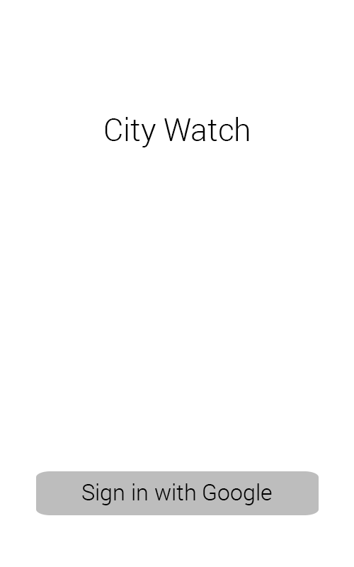
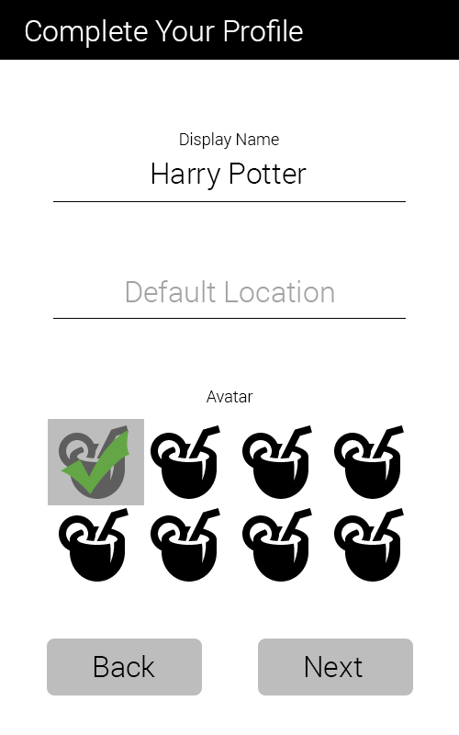

Login Using Google Account
(Mod100)
First time users will have to login using a Google account of their choice
Account Setup
(Mod200)
Before proceeding to the app itself, first time users need to complete their profile by inputting their Name, Location, and choosing an Avatar

Post Module

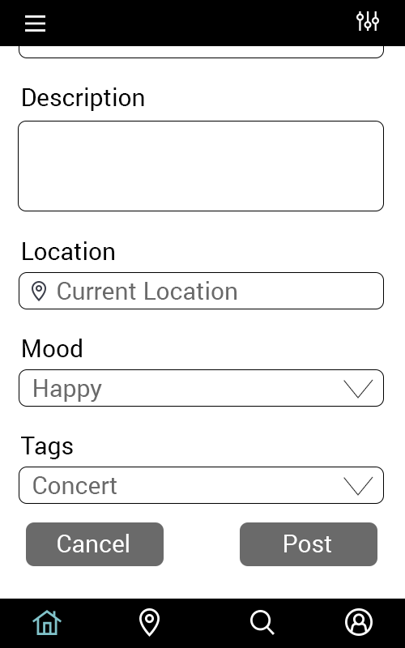
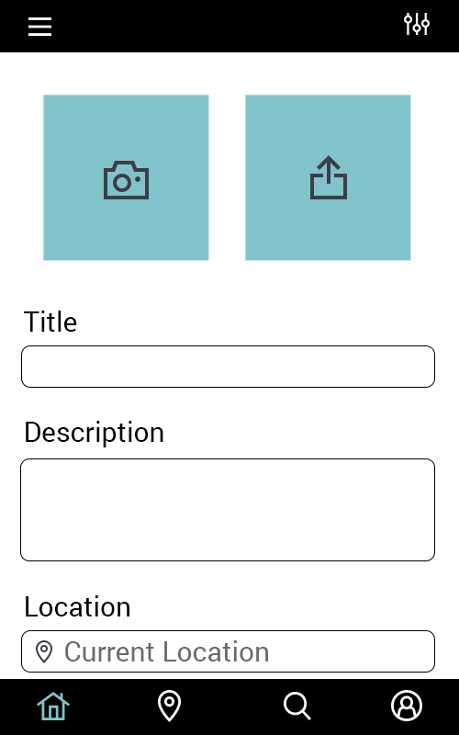
Post Module
(Mod900)
In posting, the user will have to choose between two options: take a photo/video using the phone’s default camera or import an existing photo/video from the phone’s gallery. After that, they will have to fill in the required fields (Title, Description, Location, and Tags) and the one optional field (Mood).

Feed Module

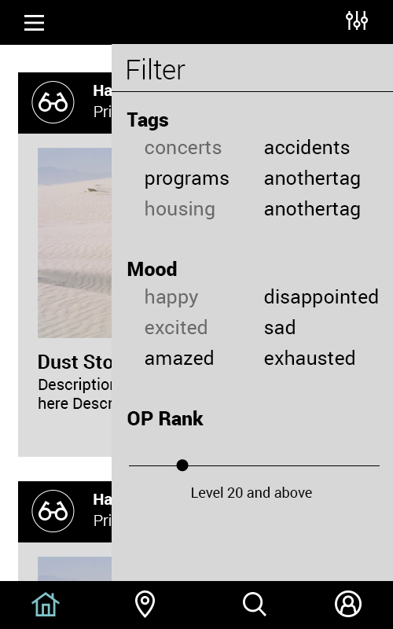
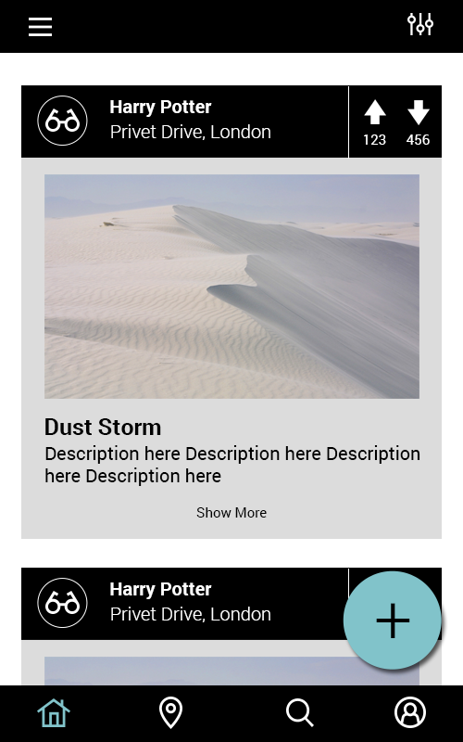
Filter Feed
(Mod403)
Users can choose the type of posts they prefer to see on their feed by filtering them.
Upvote/Downvote a Post, Go to User Profile
(Mod402, Mod408)
A user can upvote/downvote a post depending on how they judge the content (whether it is relevant or not, etc.). From the navigation bar at the very bottom of the page, the user can navigate back and forth from the WatchFeed to his/her user profile

Map Module – City Posts
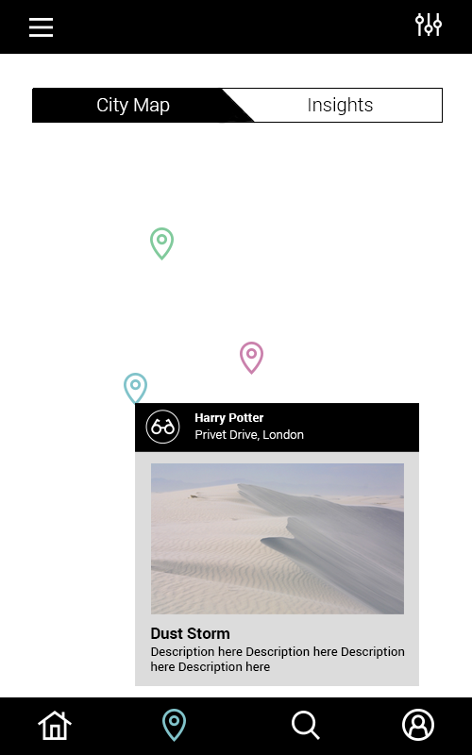

Click Marker, Click Info Tag
(Mod501, Mod505)
A user can view a Map where blips are located in the location of the post. These blips can be clicked by the user to view the Info Tag where a summary of the post is displayed. The Info Tag can also be clicked after which a new activity will open where the full post will be displayed.

Map Module – City Insights

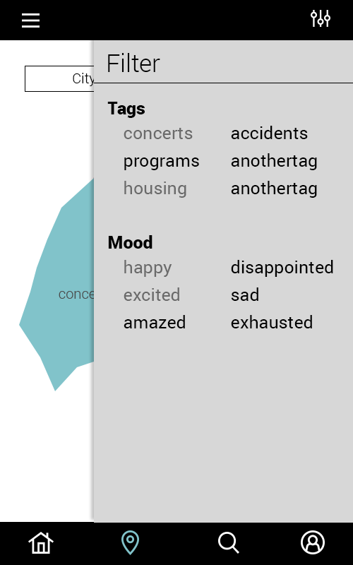
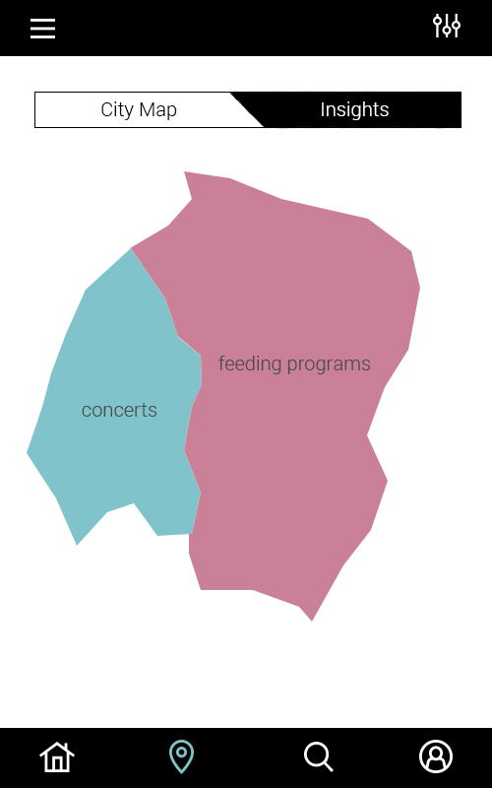
Insights
(Mod600)
This shows the heatmap where certain tags are most prevalent
Click Tags
(Mod602)
Display the regions in the map where the selected tag is most frequent.

Profile Module
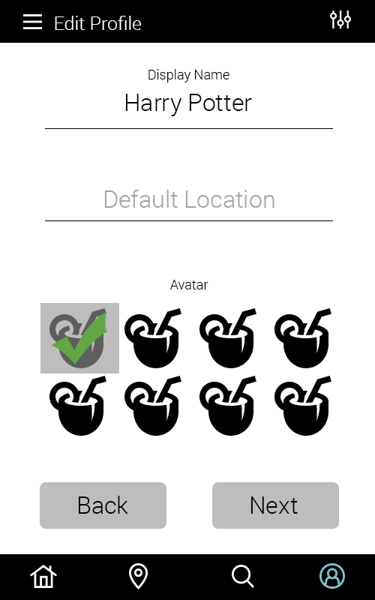
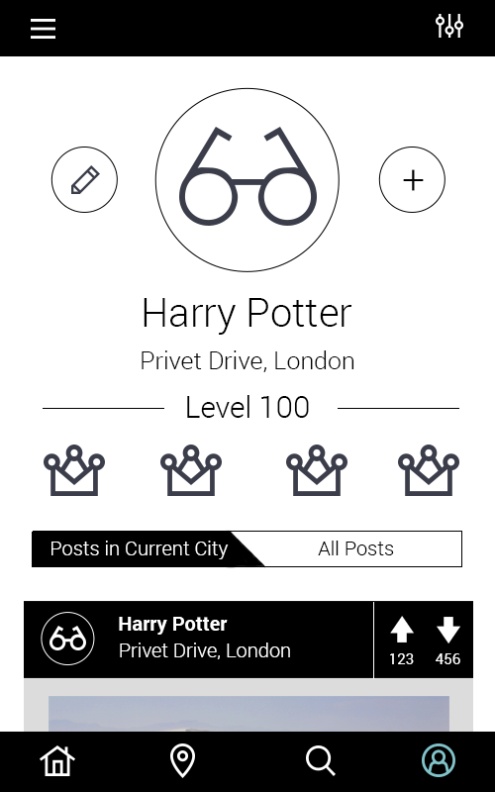
Display Profile
Here, the user’s profile can be viewed. It displays a number of things such as display picture, name, location, rank, achievements, and posts.
Edit Profile
(Mod801)
By clicking the pencil symbol, the user can edit their profile by changing their display name, location, and display picture

3.1.2. Software interfaces
This subsection enumerates all required software interfaces.
- Google Account - Google’s Account System shall be utilized.
- Google Maps - Online Navigation System provided by Google shall be utilized.
- Firebase - Online Database Service provided by Google shall be utilized.
- User Client Software - Implemented for Android devices and written in Java and XML.

3.1.3. Communications interfaces
This subsection iterates all required communication interfaces.
- GPS - Shall be used in conjunction with Google Maps

Functional requirements

3.2.1. Login Module (Mod100)
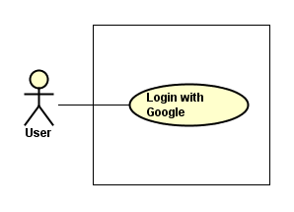
Mod101
On their first usage of the app, users are required to login using a Google account.

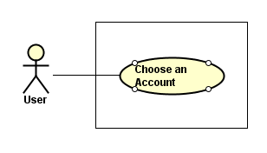
Mod102
On their first usage of the app, users are required to choose a Google Account of theirs should their phones be signed in many accounts.

3.2.2. Account Setup Module (Mod200)
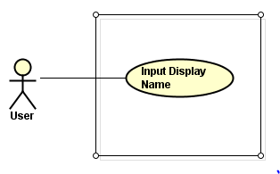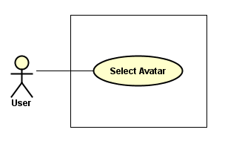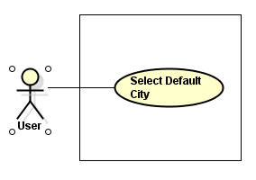
Mod201
Prior to using the app, users should input their display name.
Mod202
Prior to using the app, users should select an avatar.
Mod203
Prior to using the app, users should select their default city.

3.2.3. Dashboard Module (Mod300)
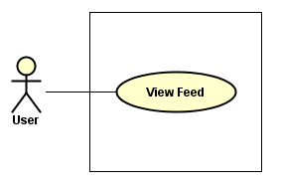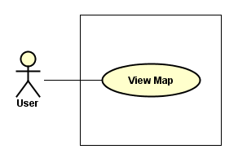
Mod301
In the dashboard, users can view the feed
Mod302
In the dashboard, users can view the map

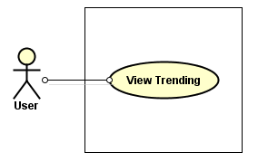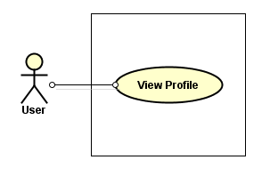
Mod303
In the dashboard, users can view the trending posts
Mod304
In the dashboard, users can view their profile

3.2.4. Feed Module (Mod400)
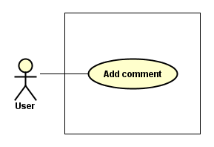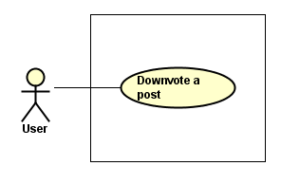
Mod401
In the Watchfeed, users can add a comment to a post.
Mod402
In the Watchfeed, users can downvote a post should they find it irrelevant, not helpful, offensive, etc.

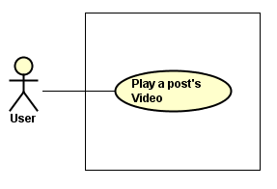
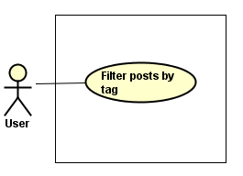
Mod403
In the Watchfeed, users can filter the posts that are displayed in it through the filter drawer.
Mod404
In the Watchfeed, users can play a post’s video (provided that the post has a video in it).

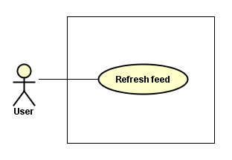
Mod405
In the Watchfeed, users can refresh the feed after which new/fresh posts will be displayed on top of the old ones.

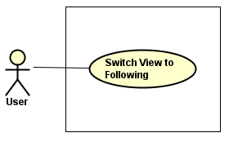
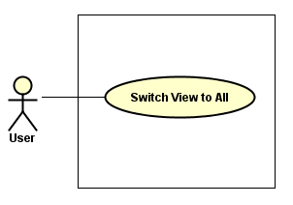
Mod406
In the Watchfeed, users can switch to view all post (in cases when their feed has been filtered)
Mod407
In the Watchfeed, users can choose to display only the posts of the users they follow.

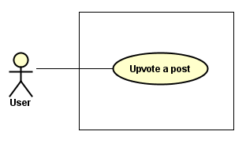
Mod408
In the Watchfeed, users can upvote a post should they find it relevant, helpful, informative, etc.
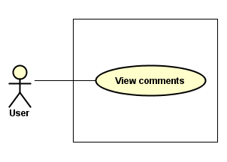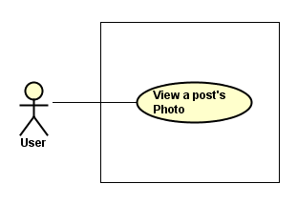
Mod409
In the Watchfeed, users can view the comments of a post.
Mod410
In the Watchfeed, users can view the photo attached to the post.

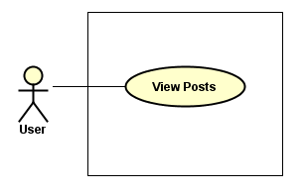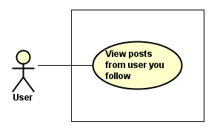
Mod411
In the Watchfeed, users can view the posts.
Mod412
In the Watchfeed, users can the posts of the users they follow.

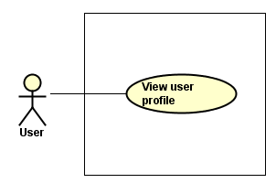
Mod413
In the Watchfeed, users can click on the avatar/display name of a user from whence he will be redirected to that user’s profile (this profile may be of another user’s or his/her own).
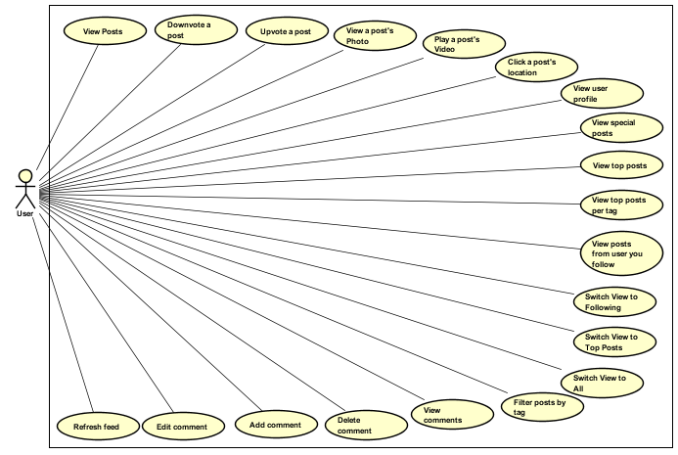
In the feed, users can do the following:
- View Posts
- Upvote a Post
- Downvote a Post
- View a Post’s Photo
- Play a Post’s Video
- View User Profile
- View Posts from the Users the User is following
- Switch View to Following
- Switch View to All Posts
- Filter Posts by Tags
- View Comments
- Add Comments
- Refresh Feed

3.2.5. Map Module – City Posts (Mod500)
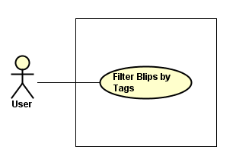
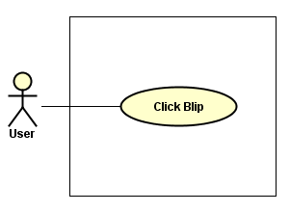
Mod501
When viewing the map, users can click the blips to display Info Tags
Mod502
When viewing the map, users can filter blips by tags from the filter drawer.

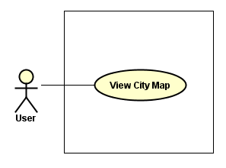
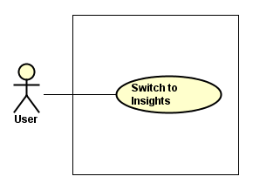
Mod503
When viewing the map, users can switch from City View to Insights where a heatmap is displayed
Mod504
When viewing the map, users can switch from City to Insights.

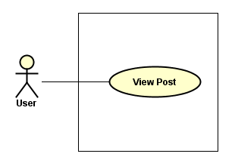
Mod505
When viewing the map, users can view the post in full-length after clicking the Info Tag.

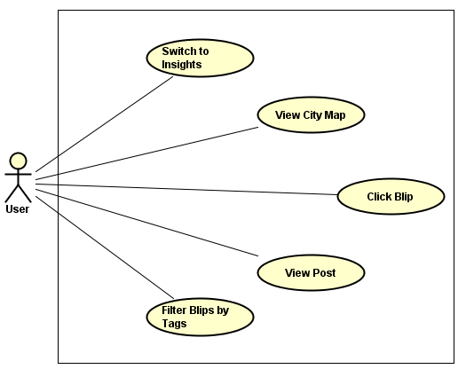
When viewing the map, users can do the following:
- Switch to Insights
- View City Map
- Click Blips
- View Post
- Filter Blips by Tags

3.2.6. Map Module – City Insights (Mod600)
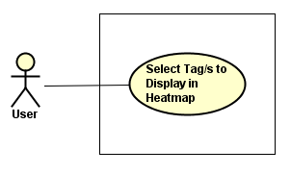
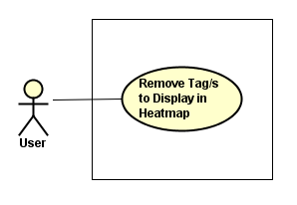
Mod601
When viewing the insights, users can remove tags that are display in the heatmap.
Mod602
When viewing the insights, users can select tags to display in the heatmap.

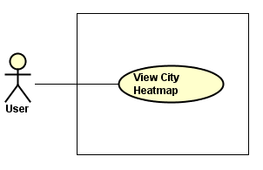
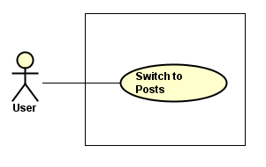
Mod603
When viewing the insights, users can switch to posts.
Mod604
When viewing the insights, user can see the heatmap based on his/her selected tags.

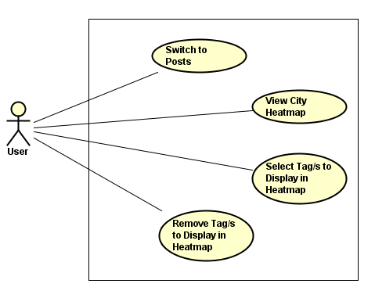
When viewing Insights, users can do the following:
- Switch from Insights to Posts
- Switch from Insights to City Heatmap
- Select the tags to be displayed in the Heatmap from the Filter drawer.
- Remove the tags to be displayed in the Heatmap from the Filter drawer.

3.2.7. Trending Module (Mod700)

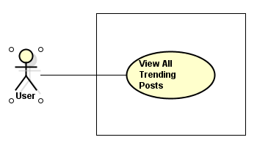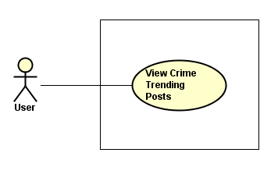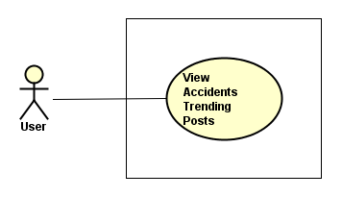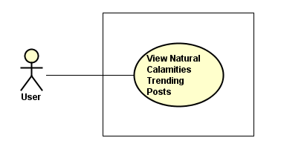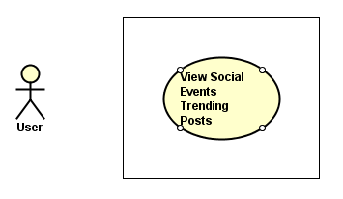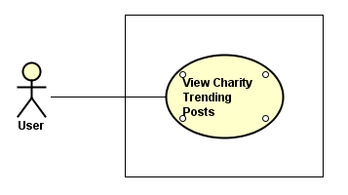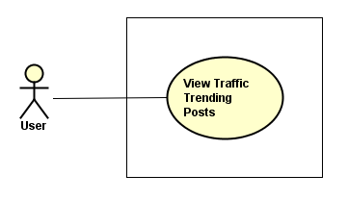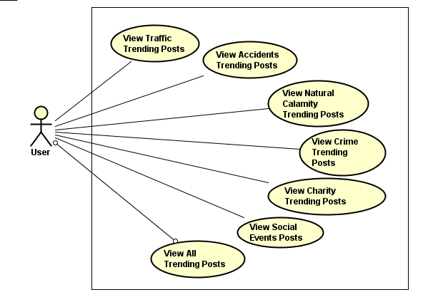
Mod701
In the Trending Section, users can view all the trending posts regardless of their category
Mod702
In the Trending Section, users can view all the trending posts in the crime category.
Mod703
In the Trending Section, users can view all the trending posts in the accidents category.
Mod704
In the Trending Section, users can view all the trending posts in the natural calamities category.
Mod705
In the Trending Section, users can view all the trending posts in the social events category.
In the Trending Section, users can view the trending posts in the following categories:
- All Posts
- Traffic
- Accidents
- Natural Calamity
- Crime
- Charity
- Social Events
Mod706
In the Trending Section, users can view all the trending posts in the charity category.
Mod706
In the Trending Section, users can view all the trending posts in the traffic category.

3.2.8. Profile Module (Mod800)
Mod706
In the Trending Section, users can view all the trending posts in the charity category.
Mod707
In the Trending Section, users can view all the trending posts in the traffic category.

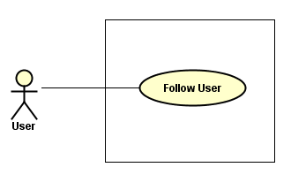
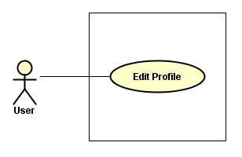
Mod803
When viewing their own profile, users can edit their own profile.
Mod804
When viewing a different user profile, users can follow that user (and his/her posts).

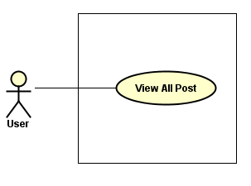
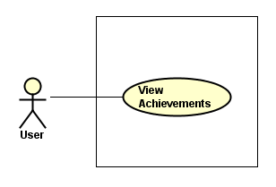
Mod805
When viewing their own profile and another user’s profile, they can view the achievements of the owner of that profile.
Mod806
When viewing their own profile and another user’s profile, they can view the posts of the owner of that profile.

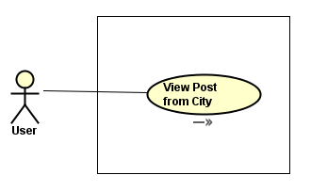
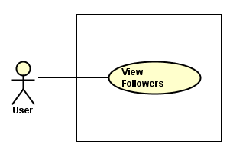
Mod807
When viewing their own profile and another user’s profile, they can view the followers of the owner of that profile.
Mod808
When viewing their own profile and another user’s profile, they can view the posts from a city of the owner of that profile.

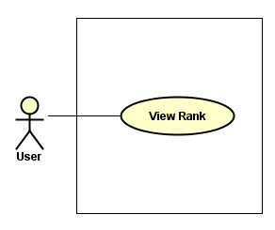
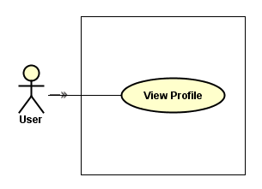
Mod809
When viewing their own profile and another user’s profile, they can view the profile of the owner of that profile.
Mod810
When viewing their own profile and another user’s profile, they can view the rank of the owner of that profile.

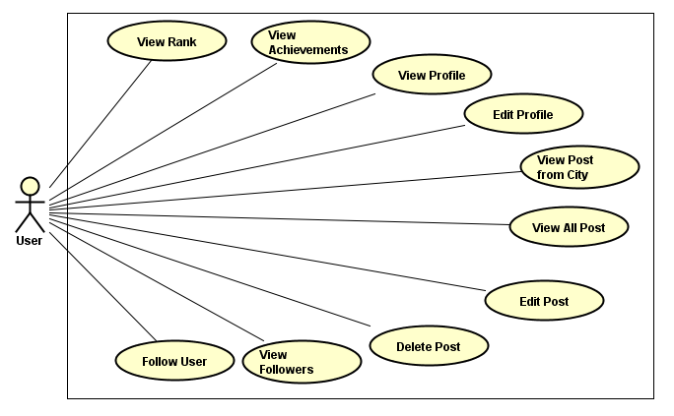
When viewing their own profile only, tusers can do the following:
- Edit Their Profile
When viewing both their profile and another user’s profile, they can do the following:
- View Profile
- View All Posts
- View Rank
- View Achievements
- View Post from City
- View Followers
When viewing another user’s profile only, users can do the following:
- Follow That User

3.2.9. Post Module (Mod900)
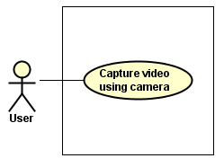
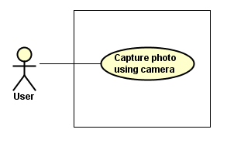
Mod901
If a user wants to post, he/she can capture a photo using the phone’s default camera
Mod902
If a user wants to post, he/she can record a video using the phone’s default camera.

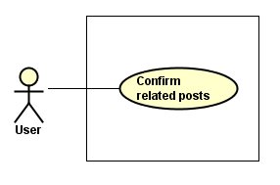
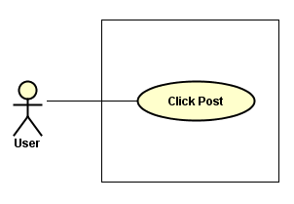
Mod903
If a user wants to post, he/she should click the “Post” button to complete the process. The post will then be displayed on the WatchFeed.
Mod904
If a user wants to post, he/she can confirm if their post is related to another post of the same content as perceived by the system. This measure is to prevent displaying a plethora of posts of the same content.

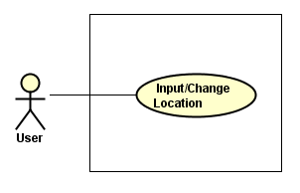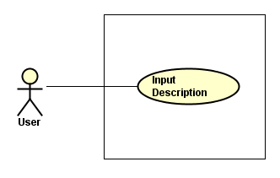
Mod905
If a user wants to post, he/she is required to input the location from which the post happened.
Mod906
If a user wants to post, he/she is required to input a description of the post.

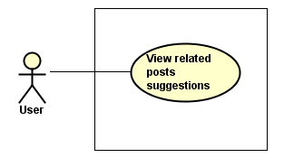
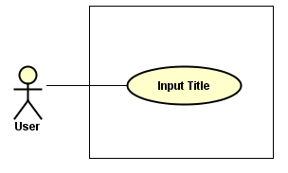
Mod907
If a user wants to post, he/she is required to provide a title for the post.
Mod908
If a user wants to post, he/she is required to provide a title for the post.

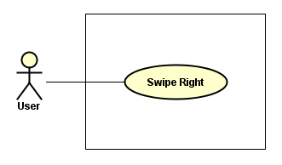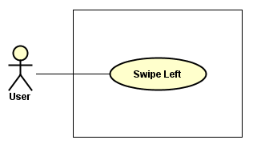
Mod909
If a user wants to post, he/she is required view potential related posts. If what they are posting is related, they have to swipe right
Mod910
If a user wants to post, he/she is required view potential related posts. If what they are posting is not related, they have to swipe left

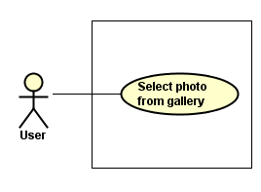
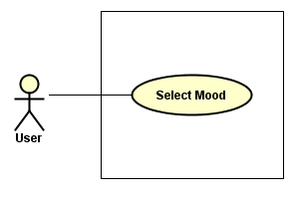
Mod911
If a user wants to post, he/she can choose from the moods to match what they feel about the content of their post.
Mod912
If a user wants to post, he/she can choose a photo from their phone’s gallery.

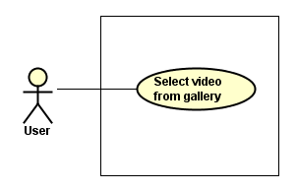
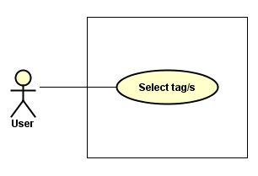
Mod913
If a user wants to post, he/she is required to choose from the tags that matches the content of their post.
Mod914
If a user wants to post, he/she can choose a video from their phone’s gallery.

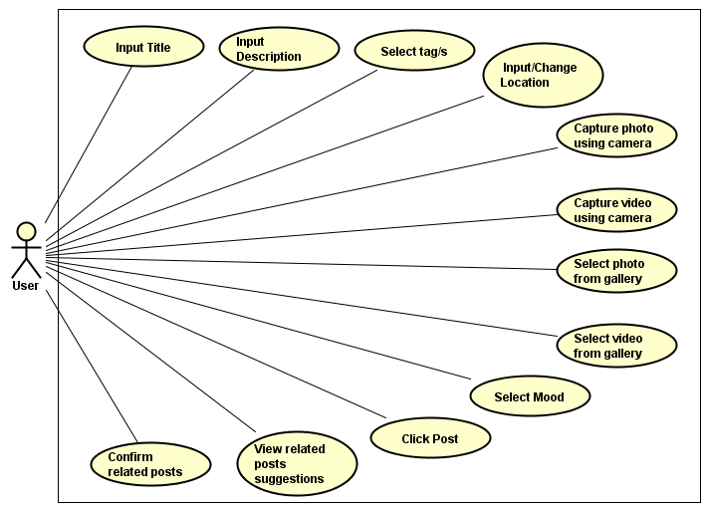

If a user wants to post, he/she is required to do the following:
- Input Title
- Input Description
- Input/Change Location
- Select Tags
- Click “Post”
- View Related Posts Suggestions (if any)
If a user wants to post, he/she can do the following:
- Capture a photo/video using camera
- Select photo/video from Gallery
- Select Mood
- Confirm Related Posts
- Click “Cancel”

3.2.10. Search Module (Mod1000)
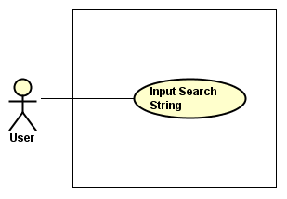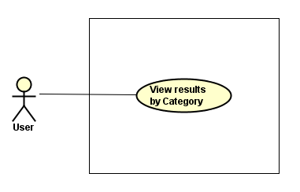
Mod1001
In the Search Bar, users can input keywords that they would like to search.
Mod1002
After searching for a keyword, users can view the results by category.
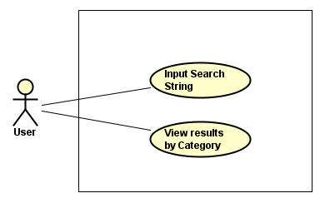
In searching, users can do the following:
- Input a keyword that they want to search about in the search bar
- View the results of their search by category

3.2.11. City Module (Mod2000)
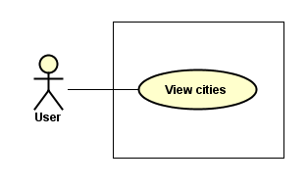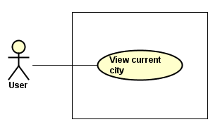
Mod2001
When viewing the city module, users can view a list of his/her registered cities from the main navigation drawer.
Mod2002
When viewing the city module, users can view the current city they are registered on.

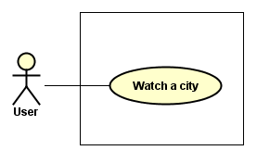
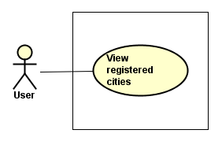
Mod2003
When viewing the city module, users can view the cities they registered.
Mod2004
When viewing the city module, users can view the statistics (number of watchers, radar map) of a city they registered.

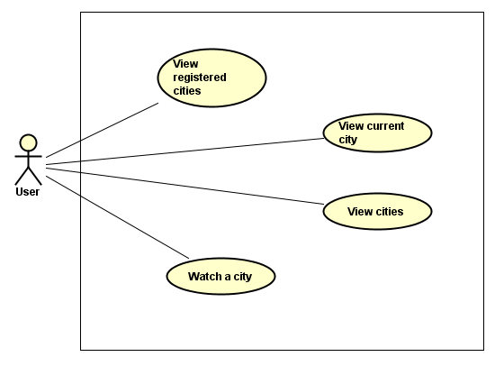
When viewing the city module, users can do the following:
- View the cities they registered
- View the statistics of their current city including the number of watchers and the radar map
- View the statistics of a certain city

3.2.12. Leaderboard Module (Mod3000)
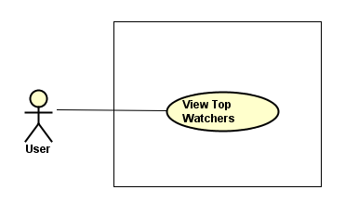
Mod3001
In the Leaderboard, users can view the list of top watchers. These watchers are those whose posts have met the criteria for top posts.
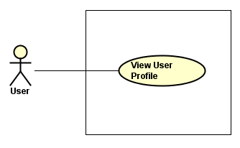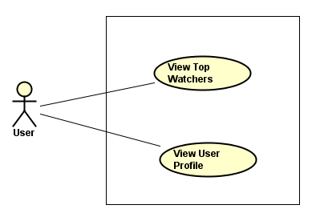
Mod3002
In the Leaderboard, users can click a top watcher’s avatar or display name from whence he/she will be redirected to that user’s profile.
In the Leaderboard, users can do the following:
- View the list of Top Watchers
- View the Profiles of the Top Watchers

Performance Requirements

3.4. Design constraints

3.5. Software system attributes

3.6. Other requirements

Appendixes

Index

